FIRST TERMINAL EXAMINATION SEPTEMBER- 2019
Marks obtained:

Total:25

Name: ____________________________
Grade: I Section___
Subject: General Knowledge
Date: 18.09.19
Time: 1 Hour

I. Choose the correct answers. (25X1=25)
1. How many letters are there in the English alphabet?
a. 22 b. 24 c. 26 d. 25
2. We use our eyes to _______________
a. see b. hear c. feel d. eat
3. Which number comes after 6?
a. 5 b. 4 c. 8 d. 7
4. How many days are there in a week?
a. 7days b. 5 days c. 12 days d. 6 days
5. What is 2+ 2=______________
a. 8 b. 6 c. 4 d. 2
6. Which day comes before Friday?
a. Saturday b. Thursday c. Monday d. Sunday
7. How many colours are there in a rainbow?
a. 6 colours b. 7 colours c. 5 colours d. 4 colours
8. How many flamingos do you see in the picture?
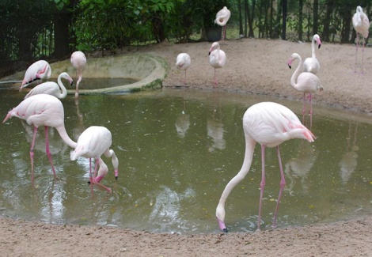
a. 12 flamingos
b. 10 flamingos
c. 5 flamingos
d. 8 flamingos
9. Which is the last month of the year?
a. January b. April c. May d. December
10. What is 5 – 2 =_____
a. 6 b. 3 c. 5 d. 7
11. When do we celebrate Independence Day?
a. 15th August b. 26th January c.13th September d. 2nd October
12. Our National fruit is _________________
a. apple b. mango c. orange d. grapes
13. Who is the Chief Minister of Tamil Nadu?
a. Selvi.J. Jayalithaa b. O. Panneerselvam
c. Edappadi K. Palaniswami d. None of these
14. We call our mother’s father as_________________
a. grandmother b. grandfather c. uncle d. aunt
15. Baby of a dog is called________
a. Puppy b. kitten c. calf d. cow
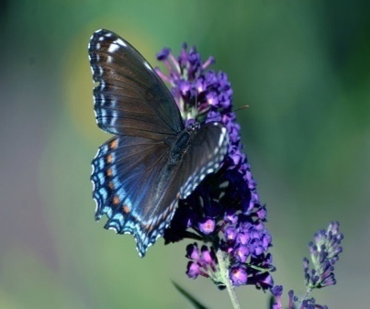
16. What type of insect do you see in this picture?
a.bee b.ant c. butterfly d. spider
17. How many months are there in a year?
a. 7 months b.10 months c. 12 months d.5 months
18. The person who brings a letter to your home from post office.
a. postman b. teacher c. driver d. policeman
19. We should drink _____________ water.
a. salty b. pure c. impure d. mud
20. How many months begin with the letter ‘ J ‘ ?
a.3 b. 4 c. 5 d. 0
21. What is meaning of tiny?
a. large b. huge c. big d. small
22. What is the next number?
5 7 9 11 13 ________
a. 12 b. 15 c. 14 d. 11
23. We all should ___________ our elders.
a. respect b. success c. best d. manners
24. Rearrange the jumbled letters
H E E P S _______________
a. Heep b. sheep c. she d. he
25. What is 8 – 5?
a. 4 b. 5 c. 3 d. 2

